NOAA Weather Information and Dissemination All Hazards Stakeholder Project: Phase 1

Prepared by the Center for Advanced Public Safety, The University of Alabama
POC: Dr. Laura Myers, Director, Center for Advanced Public Safety
Email: laura.myers@ua.edu

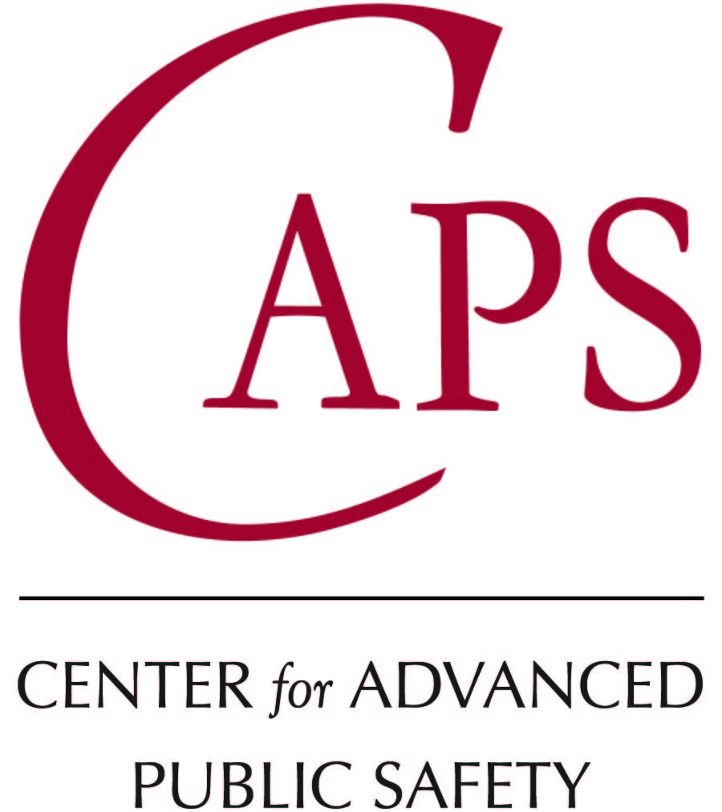

Table of Contents
1 Today’s Cutting Edge Technology of Weather Alerting 1
1.1 Overview 1
1.2 Executive summary 1
1.3 Background 2
1.3.1 The Warning Dissemination Process 3
1.4 Methodology 3
1.5 Discussion and Modalities 3
1.6 Government and Private Owned Weather Alert Systems 4
2 Weather Information/Resources Needed 6
2.1 What are the needs? 6
2.1.1 The Warning Information Life Cycle of the Public 7
2.2 Emergency Managers 7
2.2.1 Summary of Needs and Improvements: Emergency Managers 8
2.3 Broadcast Meteorologists 9
2.3.1 Summary of Needs and Improvements: Broadcast Meteorologists 10
2.4 Technology industry 10
2.4.1 Summary of Needs and Improvements: Technology Industry 11
2.5 The National Weather Service 12
2.5.1 Summary of Needs and Improvements: National Weather Service Personnel 12
2.5.2 NWS and EM Workshop Perceptions on Modalities 13
2.5.3 NWS and EM Workshop Perceptions on Beneficial Improvements 14
2.5.4 NWS and EM Workshop Current Use of Modalities 15
2.6 The Public/End User 16
3 Should NWS Eliminate, Replace or Expand NWR 18
3.1 Perspectives on NWR 18
3.2 Can it be improved for those who use other modalities? 18
3.3 If NWR ceased, what are the gaps? 18
4 Business Case Analysis 21
4.1 Perspective on NWR and other warning modalities 21
4.2 Replacement Options for NWR 21
4.3 Solutions 22
5 Recommendations 23
6 Phase 2 24
6.1 Perspectives on Weather Information Dissemination 24
6.2 Phase 2 plan 25

Today’s Cutting Edge Technology of Weather Alerting

Overview

The rationale for this study is to understand the use of technology to mass disseminate weather information and alerts. There are numerous technologies or modalities that have evolved as part of the warning process over many decades of use, with several new technologies that appear to extend the reach, timing, and importance of alerting to populations who might not have received those alerts under older, more traditional technologies. This Phase 1 Needs Assessment begins an exploration of these modalities with stakeholders who have used these technologies and can provide feedback on the strengths and weaknesses of traditional and newer modalities, providing a baseline of information for understanding the needs to modify, improve, retain, or even remove certain modalities from the warning process. The results of this Phase 1 study will be used in a Phase 2 analysis to establish design and engineering requirements, as well as cost-benefit analyses for these changes.

Executive summary

This preliminary assessment of identified stakeholder groups produced a dynamic picture of the warning alert dissemination process and the use of numerous weather alerting modalities. All the modalities, from sirens, to NOAA Weather Radio, to alert notifications, to smart phone apps all play a role in the warning process. They each have individual strengths and weaknesses, but they each are part of a composite and complex process of alerting. No one modality can do it all and for good reason. Each of the modalities alert in different ways, provide a variety of information, have different timing deliveries and they are used by end-users in multiple ways under a variety of conditions. Timing delivery and warning details are key components of the warning dissemination process. Forecasters are very cautious about issuing warnings, trying their best not to over-warn. But timing delivery is critical so a decision must be reached and executed. Stakeholders consistently pointed out that a tipping point of fifteen minutes can make a difference between life and death. As such, none of the stakeholders interviewed for this assessment indicated that any of the modalities should be eliminated because each one plays a role in that process. Eliminating any of the modalities would create new gaps in the warning process and even new advances to some of the modalities would not likely overcome all of these gaps. Stakeholders did provide suggestions for improvements and advancements of modalities that would overcome modality weaknesses and improve the warning alert process. Improvements are all about better timing delivery and providing the most critical details.
The primary modalities for use by end-users were identified as “good” smart phone apps, television, and alert notifications, followed by the more traditional modalities of NOAA Weather Radio and sirens. All of these modalities were highlighted as part of the warning alert process for their end-user constituencies, along with their strengths and weaknesses in the process. Broadcast meteorologists indicated that they recommend a “good” smart phone app and NOAA Weather Radio (NWR) to their audiences to make sure they have redundant alert modalities and the coverage that the apps and the NWR provide. The smart phone apps provide excellent transient alerting and provide timely and good alert information, but not always the critical information. Because not all demographics like or use smart phones, the NWR is the traditional alternative and a favorite of older demographics, boaters, and families who want a direct alert in their homes or around water, especially for nighttime alerting and reliable timely alerting. Emergency managers (EMs) indicate that smart phones, NWR, alert notification systems, and sirens are critical in their dissemination process to partners and end-users. EMs rely heavily on alert notification systems and sirens as common public notification systems. Alert notification systems, such as Everbridge and WeatherCall, are systems purchased by communities. These systems are used to notify their residents by phone, text, email, and in some cases mobile apps. These systems provide geo-located warnings to people, but suffer from bandwidth issues due to the number of calls being made at one time. This is problematic when storms are moving faster than the staggered sets of calls being processed by cell systems. This can result in warning calls not being received until after the storm reaches the recipient’s location. Sirens are used to alert counties or sections of counties, based on siren policy in a given location. Sirens were designed for outdoor use so they will not work for people inside a structure expecting to be able to hear a siren. County-based siren usage also creates perceptions of false alarms.

Background

The background for this needs assessment is to provide NOAA with an understanding of the use of weather information for decisions – broadly, use of weather alert and warning technology specifically, and how they are used by critical stakeholders in the weather warning process. The goal is to understand the current role of the National Weather Service in the warning dissemination process and to make recommendations on their future role, and the best position to support IDSS, WRN, etc. in the evolution of warning modalities. The diagram below visualizes the warning dissemination process as it was discussed with stakeholders and also provides a framework for discussion of the needs assessment results.

The Warning Dissemination Process

Methodology

The needs assessment methodology is a multi-stage process and the Phase 1 part of the methodology involved identifying the primary stakeholder groups and contacts within those groups. A lead was identified for each group and led the initial documentation of contacts for the groups. The social science lead met with each stakeholder group lead to analyze the important warning process issues for the group and to determine important group members to be interviewed. The warning process was used to situate or give context to the inquiry as a means to focus the discussion and obtain feedback. Future engagement will look more fully into a wider span of mass dissemination of weather information. For Phase 1, it was determined that the assessment would focus on internal government partners, emergency management, broadcast meteorologists, and the technology industry. Focus groups, surveys, workshops, and interviews were used to gather data from identified contacts from the groups.

Discussion and Modalities

A primary focus of the needs assessment was NOAA Weather Radio, but in order to fully understand the needs associated with NWR, stakeholders were asked to discuss the warning process and all relevant warning modalities. This would provide the social science research team with an overview of how the stakeholders engaged in the warning process, how they use various warning modalities, and would provide them comparison points and baselines to discuss the process. The most common modalities that they discussed are listed and briefly defined below.

Government and Private Owned Weather Alert Systems

IPAWS: Integrated Public Alert & Warning System is the nation’s alert and warning infrastructure provided by FEMA. IPAWS provides public safety officials a way to issue alerts using the Emergency Alert System (EAS), Wireless Emergency Alerts (WEA), NOAA Weather Radio and other public alerting systems.
WEAs: The Wireless Emergency Alert system allows government officials to send out targeted emergency alerts to specific geographic areas.
FEMA Mobile App: FEMA’s free mobile app allows users to receive NWS alerts for up to 5 locations in the US, obtain detailed safety information, upload and share disaster photos, and has the ability to easily toggle between English and Spanish.
NWR: NOAA Weather Radio is a nationwide network of radio stations broadcasting 24/7, weather broadcasts and warnings directly from the NWS.
Outdoor weather sirens: City or county operated and managed by Emergency Management personnel.
Everbridge: Everbridge offers mass notification alerts that are location aware and secure. Everbridge users such as Emergency Management Teams can send out notifications to individuals or groups using lists and locations. Everbridges targets the user rather than the device using voice recording, texts, phone calls, email, text to speech conversion in multiple languages, and push notifications requiring the recipients to respond.
WeatherCall: WeatherCall is a severe weather notification system and according to their website is in approximately 85+ weather sensitive local TV markets around the US. WeatherCall offers 4 versions: WeatherCall @Home, WeatherCall ToGo, WeatherCall Enterprise, and WeatherCall for Schools. Weather Call issues lightning strike warnings within 6 miles of a person’s location and 1 mile for severe thunderstorm, flash flood and tornado warnings.
WDT (Radar Scope and iMAP Weather Radio): WDT offers two mobile apps, Radar Scope and iMap Radio. Radar Scope allows users to view NEXRAD radar data. Weather Radio offers polygon based push notifications and lighting alerts.
BARON SAF-T-Net/Alabama SAF-T-Net: Alabama uses a free weather alerting services known as Alabama SAF-T-Net. Users can utilize the Alabama SAF-T-Net, notifications via text or email. Users can also opt to receive automated phone calls on a landline phone. Notifications include incoming hail, wind, rain; tornado warnings, severe thunderstorm warnings, and flash flood warnings. Notifications may also include custom messages with alert and safety information from local Emergency Management.
NWS Chat: NWSChat is an instant messaging program used by NWS partners for obtaining real-time, critical warning decision expertise directly from NWS personnel.
NWS WFO Webpages: Each NWS Weather Field Office (WFO) has its own webpage with county warning area (CWA) weather information. Information is provided to partners and the public, including radar and forecast information.
Storm Prediction Center: The SPC is part of the National Centers for Environmental Prediction (NCEP) model and provides an 8 day outlook, forecasting the risk of severe weather: thunderstorms, hail, strong winds, tornadoes, hazardous winter and fire weather.
Weather Bug: Weather Bug maintains a mesonet of over 8,000 weather stations and offers a mobile application, including Spark, its lightning alert system.
The Weather Company (previously known as WSI): The Weather Company provides technology platforms and services for media, aviation, energy, insurance, government, and retail. Products like Max Engage offer geo targeting, push notifications, visual technology, and the ability to boost broadcast through mobile and social media. They also own and operate weather.com (Weather Channel), Intellicast.com, and Weather Underground.
Weather Underground: Weather Underground provides real-time weather information on its website to major cities around the world, as well as to local weather outlets. Owned and operated by the Weather Company, they receive most of their information from the NWS but also rely on observations from over 100,000 personal weather stations (PWS).
Weather Channel: The Weather Channel, a product of the Weather Company, broadcasts weather forecasts, weather-related news, analysis and documentaries. In addition to cable broadcasts, TWC also provides weather forecasts and alerts to satellite radio, newspapers, websites and mobile applications.
TV Broadcast Stations: Local television networks provide weather information during newscasts, specialized weather event coverage, as well as social media and website information.
AlertFM: Alert FM uses local FM stations to deliver alerts to state, local, and/or private sector. Alert FM messages are transported using a satellite data delivery system. Currently alerts are received on Alert FM receivers (mobile, wall mounted, or USB) or on cell phones equipped with FM chips. Receivers can be programmed to receive local NOAA weather alerts.
AWARN: AWARN’s predecessor is the nation’s current mobile Emergency Alert System (EAS), providing presidential access if a national emergency were to occur and for broadcasters, cable systems, and satellite operators messaging capabilities during man-made and natural disasters. AWARN is a proposed update with the upcoming ATSC 3.0 broadcasting system that would use existing television broadcasts to issue live TV emergency alerts to an unlimited number of handheld, vehicular, or other receivers.

Weather Information/Resources Needed

What are the needs?

To determine the major needs, the interview goal was to have stakeholders discuss warning modalities and their strengths and weaknesses. They were asked to do this by comparing the warning modalities in reference to what the warning modalities can and cannot achieve for the warning dissemination process. The consistent findings across all interviews were:
- Warning dissemination is a process and each warning modality plays a role in the process. While each modality has its strengths and its weaknesses, all the modalities play a role in the process and it is vital to understand the process. Removing or weakening any of the modalities would dangerously impact the warning process. The National Weather Service (NWS) provides the warning information directly to these stakeholders and then they further disseminate that information through multiple modalities with the intent to reach as many partners and residents as quickly as possible. All stakeholders supported the view that “layers save lives.” The more warning modalities and dissemination paths the better. In the meantime, the NWS continues to disseminate it themselves through as many modalities as possible.
- In a comparison of all of the modalities, the key information to disseminate is geo-located, storm based warnings, polygon based information, with timing and details, with as much lead time as possible. The goal is to make the message more immediate, more location based, and include impacts and timing. In reviewing each of the modalities, each one can do most of these things but not all, so efforts to improve or modify these modalities should be focused on these elements. The stakeholder groups provided significant input on the improvements and modifications that could be made that would achieve these important warning elements.
- Warning information needs change over the life cycle of the public. It is important to understand those needs by age evolution to understand the connection between their needs and the way weather information is disseminated to them. This life cycle is also complicated by the shear numbers of people in those age groupings. As the Baby Boomer life group ages and their needs start to impact the warning dissemination process, there will be more demands on the process and the methods by which they want to get weather information. It is also critical to understand that as people move through the various life cycles they evolve from an individual centric world-view to a family and community centric world-view that is more concerned with safety and security. Chart 2.1.1 shows the changing focuses and concerns of people as they age in regard to their demands for warning information.

The Warning Information Life Cycle of the Public

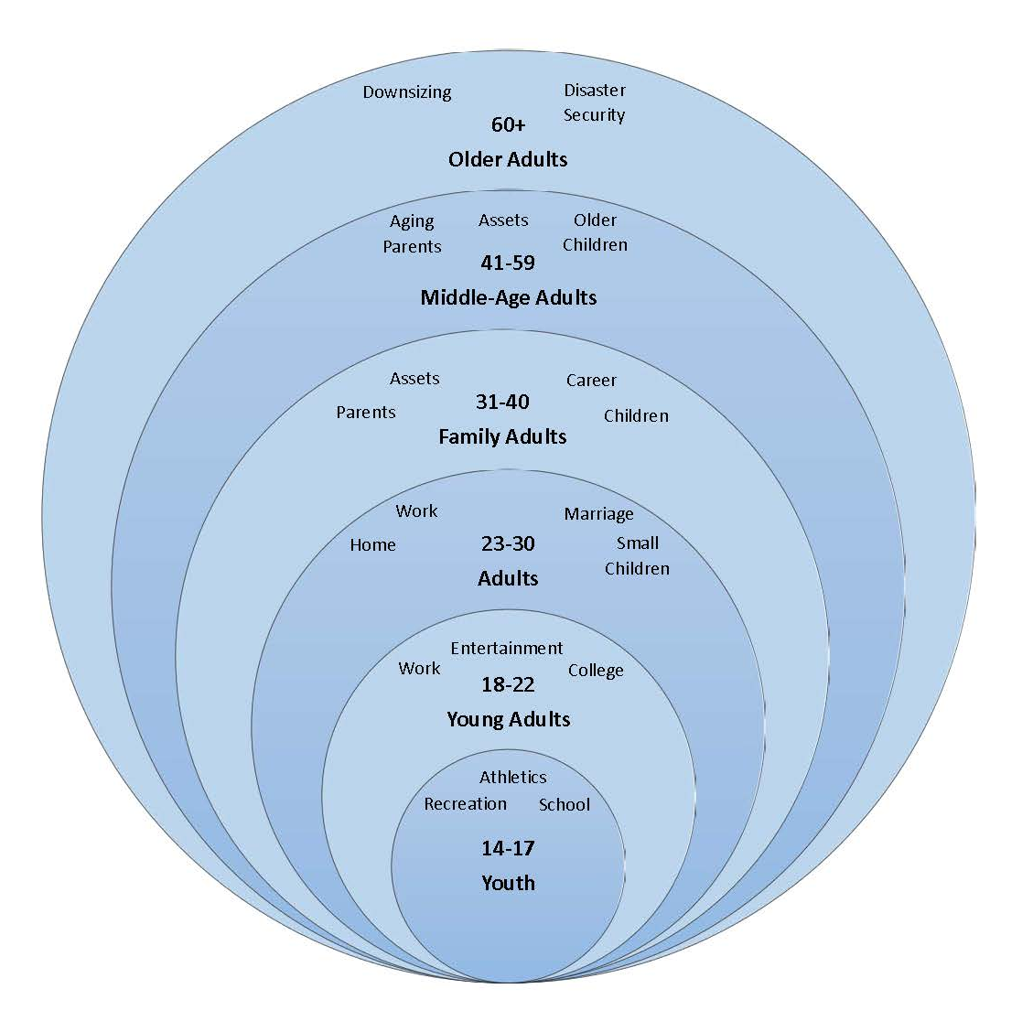

Emergency Managers

Emergency managers report the need for multiple modalities of weather warning dissemination. Their mission as emergency managers is to gather warning information and disseminate it to their partners and to the public. They use multiple modalities in their offices, home, and vehicles to gather that data and then they disseminate it or support dissemination using all the modalities identified in this assessment. When asked about the utility of each of the modalities, they identify unique needs for each modality and primarily the need for redundancy. They also indicate that there is a need for information, pre-event, during the event, and post-event so they need weather information at all of these stages.
Everyone clearly defined the weaknesses and failure points of each of the modalities. Mobile alerts and notifications work well for specific demographics, generally those with smart phones and those who have adopted technology, but those who do not use smart phones rely on more traditional modalities such as sirens, NOAA Weather Radio, and television. During any given event, any of these modalities can fail or can be the first alert for any given demographic. Mobile alerts can suffer from bandwidth issues resulting in notification delays. Social media is not a first alert notification system at all. It may be the first one observed by the user, but timing is an issue. WFO website information is not real time and does not serve as initial notification and will suffer from delays in updating during actual events. WEA alerts suffer from the 90 character limitation, reducing the amount of content that can be sent using the alert.
Emergency managers are huge fans of alert notification systems, such as Everbridge and WeatherCall. These systems are purchased by local government for use by their residents and provide warning alerts via landline and cell phone, text, email, and even apps. For emergency managers, speed of the warning dissemination process is a big motivator and alert notification systems help them achieve that goal.

Summary of Needs and Improvements: Emergency Managers

Needs | Tools | Preferences | Gaps | Improvements
Fast dissemination | Alert notification systems, NWR, social media, NWS Chat, mobile apps, and any other tools that add information. | Alert notification systems | Reaching vulnerable populations.  Deaf and hard of hearing.  Transient populations.  Language differences. | Improve bandwidth issues for alert notification systems. Use best practices of fast dissemination systems.  Focus technology development on reaching vulnerable locations.
Information at all stages of an event | NWS Chat, IDSS, NWR | No preferences | Need more pre-event IDSS.  Need post-event information to manage recovery. | Expand NWR to provide more pre-event and post-event information.  Expand use of NWS Chat to more partners. Develop technologies to enhance IDSS, especially the ability to transmit IDSS to as many partners as needed, such as video conferencing.
Location and Timing | NWR, mobile apps, sirens, television, WEAs, alert notifications | Anything that shows location and timing graphically and in the quickest way possible. | Storm based, polygon based warnings.  Geo-location. | Make sure all modalities provide location and timing with updates. Make sure all modalities provide geo-location.
Lead time | All modalities | NWR, alert notifications | Bad connectivity in rural areas.  Nighttime warnings. | NWR needs to be geo-located, polygon based.

Broadcast Meteorologists

Broadcast Meteorologists (Broadcast Mets) provided a very comprehensive analysis of the warning modalities and how those modalities work for their audiences. Broadcast Mets focused on their role in the process and how the public and emergency response partners turn to television at some point in the warning dissemination process. As a result, they have a great perspective on what information the public and partners want and how they want to get it. All indicated that their main mission is dissemination and they are passionate about helping the public get the information they need.
To that end, Broadcast Mets consistently educate their audiences about how to get warnings and alerts. They recommend multiple modalities since all modalities have some shortcomings and because time will always be the factor. Having multiple modalities allows people to have the best chance at getting the warning as soon as possible. They recommend NOAA Weather Radio, good smart phone apps, alert notification systems, sirens, social media, the Internet, and television. Their intent with the recommendations is to have the public get a first alert of some kind from one or more of these modalities and then turn to television for more information.
When asked about the consequences if NWR were no longer available, they indicated that the demographics of older people, boaters, and families that NWR serves would likely not receive early alerting. They also indicated that they have spent an enormous amount of time educating their audiences about NWR so if they were to quit recommending it, they would look foolish to their audiences. They believe NWR is vital regardless of the numbers it serves because we don’t actually know the consequences if NWR were not in use. Broadcast Mets don’t want to take that risk. They do recommend that NWR be improved to be storm-based because that would provide more information to the NWR user and could reduce the perceptions of over-warning.

Summary of Needs and Improvements: Broadcast Meteorologists

Needs | Tools | Preferences | Gaps | Improvements
Multiple modalities | NWR, Mobile Apps, Social Media | All of these | NWR is not storm-based. | Make NWR storm-based.
Storm-based tools | NWS products, mobile apps | Anything that shows location and timing. | NWR is not storm-based. | NWR needs to be storm-based and geo-locatable.
End users | NWR, mobile apps | Risk communication | Vulnerable populations need options | Reduce annoyances with NWR.  Upgrade NWR technology.  Manage NWR transmitter maintenance better. Need more transmitters in locations where these vulnerable populations need NWR-coastal, lakes, recreation areas, etc.

Technology industry

Technology manufacturers of the NWR, AlertFM, alert notification systems, and mobile apps were interviewed to get their perceptions on their own modalities and the strengths and weaknesses of each. To counter conflict of interest bias, we interviewed all stakeholders about these technologies to get a complete understanding of strengths and weaknesses, as well as a variety of suggestions for improvement.
NOAA Weather Radio strengths include having an in-home alerting system directly from the National Weather Service. NWR’s programming has been simplified for the end-user, which has overcome the programming frustrations associated with the product. NWR appears to be a favorite of older populations and families because of the quick alerting function. It’s especially useful for nighttime alerting when other modalities might not be heard. NWR is also useful to those engaged in marine activity as it allows them to receive marine warnings better than any other modality can provide. NWR does appear to annoy end-users with the constant warnings and the amount of details provided, but just as many end-users appear not to be annoyed. Major weaknesses with the NWR include the county based warning function and the transmitter functionality problem. Other modalities permit storm-based warnings, but NWR currently does not. There is a need to develop this functionality in the NWR, which would permit the NWR to be comparable to other modalities, which already provide storm-based warnings. End-users really appreciate storm-based warnings as it meets their needs for location and timing to take better action. Currently, as NWR awaits development into a storm-based warning product, it can actually be programmed to reduce the county warning area. For example, a large county can be subdivided into three smaller locations and the NWR can be programmed to differentiate between those three subdivisions, thus reducing the area of the warning coverage, much like a polygon would. The other major weakness involves transmitter outages and the need for more transmitter locations. Reliability of NWR is impacted by the functionality and location of transmitters so efforts to improve maintenance of the transmitters and to make sure there are plenty of them in the right locations is critical.
Mobile apps and alert notifications are great newer modalities that allow end-users to receive the warnings wherever they are and in whatever forms they like to receive them, be it phone call, text, email, etc. Mobile apps are only as good as the data being used so the better mobile apps are those that use the most current, geo-located, accurate data and push it to the end user. Alert notifications seem to be a great alternative to the NWR because it provides much of the same data in a simple way. A person who uses NWR can also get a phone call from an alert notification push. However, the NWR message may get to them before the alert notification call because of cell service bandwidth issues. Alert notifications go out in batches and if the storm is moving very fast, the bandwidth iterations may mean the storm arrives before the alert does.
Sirens are a major modality in many counties and suffer from being outdoors where people may not hear them and also not being storm-based. Some EMs have changed their siren policies to be polygon based, improving the situation, but many others still use county-based warnings and their siren policies may be inconsistent and confusing to end-users.

Summary of Needs and Improvements: Technology Industry

Needs | Tools | Processes | Gaps | Improvements
Fast and detailed warnings | NWR | Comes directly from the NWS.  Very fast and detailed. | Not polygon based. | Polygon based and geo-locatable.  Make sure vulnerable populations still have this option, but in improved form.  Support for only specific locations and populations.
Warnings on the go | Mobile apps and alert notifications |  | Not often enough detail. | Need more character allowance, images, and push notifications with alerting.
Nightime warnings | NWR and mobile apps |  | Sirens cannot be used for nighttime warnings. | Make sure mobile apps have the capability to alert at night.

The National Weather Service

Workshops and interviews were held with personnel from the National Weather Service at various locations around the country to determine their views on NWR and the other modalities. Warning Coordination Meteorologists (WCMs) and Meteorologists in Charge (MICs), along with WFO forecasters expressed tremendous support for NOAA Weather Radio, the WFO websites, social media dissemination, and their own internal communication tools such as NWS Chat and partner briefings. WCMs work directly with community partners and stress the need for multiple modalities, including NWR. WCMs indicated that many of their partners rely on NWR directly for first alerting, especially schools, hospitals, and businesses because they need as much lead time as possible to initiate their emergency plans. Any improvements to NWR would help these partners with lead-time issues. For example, if NWR could give these partners pre-event notifications such as “this will be a bad weather day” then the school administration would know to be listening for watches and warnings as they are issued. The NWS personnel discussed their role in the warning dissemination process as trying to get the warnings out as quickly and in as many ways as possible. They are very tuned into the need to provide location, timing, and impacts and they acknowledge that it takes multiple modalities to reach as many people as possible, regardless of the weaknesses of the modalities. The WFOs develop strong relationships with their partners to provide understanding of their products. They use internal and external communication methods to provide that understanding. NWR is their most direct communication to the public, but they use NWS Chat and video conferencing technologies to provide decision support services and product explanations to their partners prior to and during weather events. NWS also uses social media to convey information and have developed graphics and messaging to fit the various social media platforms. NWS personnel feel that social media is an important gap filler in the communication process, even though they fully acknowledge that social media is not a direct alerting modality.

Summary of Needs and Improvements: National Weather Service Personnel

Needs | Tools | Processes | Gaps | Improvements
Partner warning | NWR, NWS Chat, NWS products, website | IDSS, pre-event planning | Product complexity.  Overwarning. | Provide storm-based information to the NWR.  Provide more pre-event details.
Public warning | Social media, website | Risk and crisis communication | Website is not updated enough.  Social media can only drive traffic to other sources. Not an alert modality. | Improve website user interface for best purposes and educate partners and public on use.  Improve social media content.
ALL CLEAR information | NWR, products | Warning and watch expirations are part of the process. | This information does not appear to be coming though the modalities with any consistency. | Require ALL CLEAR/warning expirations in all modalities.

The graphics below depict some of the results from a small, in-depth workshop with National Weather Service personnel and emergency managers. These results demonstrate some of the patterns seen in all of the needs assessment interviews.

NWS and EM Workshop Perceptions on Modalities

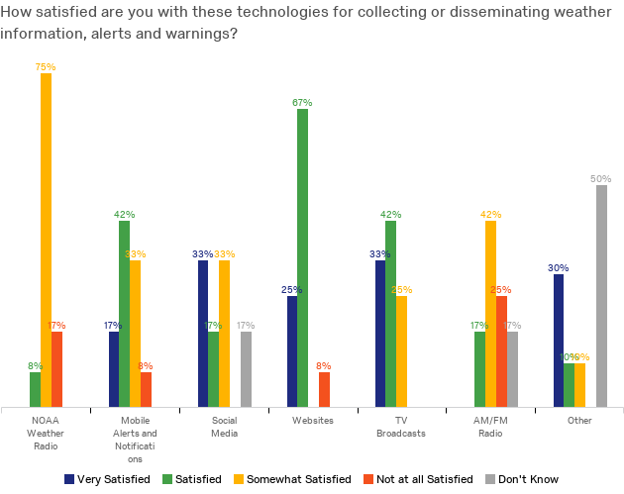

NWS and EM Workshop Perceptions on Beneficial Improvements

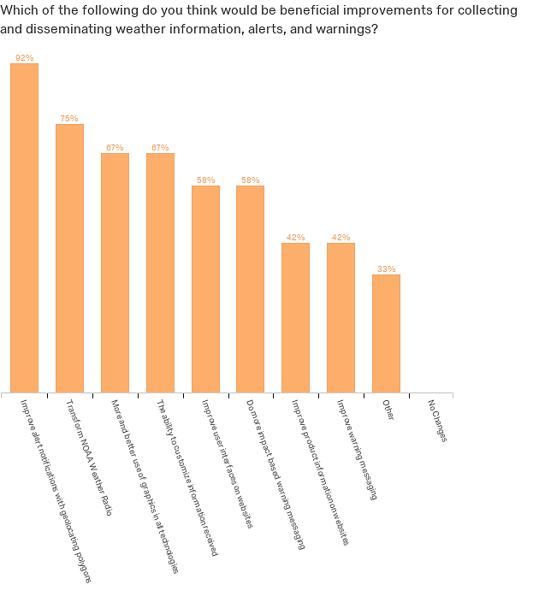

NWS and EM Workshop Current Use of Modalities

The Public/End User

Results from previous warning communication studies of the public were used in discussions with the stakeholders to identify the needs of the public when it comes to warning dissemination. The goal of this analysis was to have the stakeholders explain how warning dissemination works for their publics and how it might be improved. The needs of the public that were identified by the stakeholder groups included:
- Multiple warning modalities and redundancy: The goal is to reach the public using as many modalities as possible, knowing that different people will receive it in different ways and that there will be modality failures that may cause people not to be warned as they expect to be. Alert notifications suffer from bandwidth issues and may be delayed in transmission so having a NOAA Weather Radio (NWR) as backup will help with this issue. Relying on NOAA Weather Radio at home means needing an alert notification at work, the car, and in locations where you don’t have access to NWR. Social media may reach people but may not alert them. A NWR transmitter may go down so alert notification or television may be the only sources available.
- Detailed information: In comparing what the public prefers to use for their warning message delivery, one of the unique positive aspects of the NWR messaging was the detailed information provided. Other dissemination modalities provide the alert and warning and maybe some details, but the NWR message provides more details on location, timing, and potential impacts.
- Location and timing: The most significant needs of the public and the partners are location and timing. The public consistently indicates that any warning messaging without location and timing will send them in search of that information. They tend not to take action without location and timing. So any warning modality they use or see needs to include location and timing if it is to have the greatest chance of getting people to take action.
- False alarm reduction and overwarning: Related to the issues of location and timing, are modalities that add to the perception of false alarms and overwarning because the warnings are not specific to location and time. Modalities such as NWR and sirens that are not polygon based result in county-based warnings. County-based warnings are not specific enough for the public, especially if they live in a large county. People complain of false alarms and being over warned so they question the utility of NWR and sirens.
- Nighttime warnings: In certain parts of the country, such as the Southeast, severe weather can occur overnight, creating the need to warn people while they sleep. The public’s general perception is they will be awakened by some type of alert or warning, whether it is a siren, a NWR tone, a cell phone alert, a phone call, or some other modality they typically count on during the day. There is a need to educate the public about which modalities work best at night, which means knowing which ones are not as reliable at night, such as sirens which won’t likely be heard in the house while someone is sleeping.
- Transient warnings: There is a need to make sure that the public is warned when they are not at home and work. When they are traveling and when they are in unfamiliar locations, which modalities should they have for warning notification? Cell phone alert notifications, local sirens, and phone apps, may be useful in such situations.
- Partner notification: Emergency partners need early notifications for planning purposes. These partners include emergency management, departments of transportation, hospitals, schools, local government, and other entities that have to start planning processes early in an event cycle. These partners can benefit from decision-support services (DSS) from the National Weather Service, NWS Chat communications, NWS webinars and conference calls, and all other warning message modalities. NWR is found in many of these partner locations and serves as a primary notification modality in addition to other technological modalities.
- Impacts: There is a clear need for the public and partners to be aware of potential impacts for taking action and planning purposes. The inclusion of impact information in warning modalities is essential, whether it be the NWR messaging, social media, television weather broadcasts, and even weather blogs. The key issue is how to include impact information in the various messaging formats and also where to include it in the message given its importance to the end user. Current character limitations of some modalities actually prohibit the ability to expand these details.
- Noise: A critical issue is that warning modalities must cut down on the noise factor. If alerts and notifications annoy the end-user, they will turn off the modality and ignore its utility. All modalities suffer from some level of annoyance and should be improved to reduce this problem. A major complaint about NWR is that it alerts on everything and some things are more annoying than others, such as the numerous warnings about floods. Current efforts at hazard simplification would be useful here.
- Communication issues: Service assessments and research studies have revealed problems in communication, such as language differences, cultural differences, generational differences that must be accounted for in the warning process. All warning modalities must be able to communicate in multiple languages and account for cultural and generational perceptions of the communication. ALL CLEAR information also must come through these modalities to permit people to know the weather danger is over.

Should NWS Eliminate, Replace or Expand NWR

Perspectives on NWR
All stakeholder groups discussed NWR and its use, utility, and the needs for improvement. No individual interviewed for this study suggested eliminating NWR, regardless of the limitations they may have expressed about NWR. In these discussions, stakeholders were asked to discuss the warning dissemination process and the role of all possible modalities in the process. All stakeholders indicated that they use and recommend the use of multiple modalities. Many of them use NWR as one of their modalities, especially as backup and for redundancy with their additional modalities. The modalities given the most support would be good smart phone apps and alert notifications. They all indicated that NWR is a good modality for the home and a good modality those who don’t use technology like smart phones, those who have traditionally used NWR, and institutional partners who want a first alert. To eliminate NWR for those people would remove the primary modality they use and it would not be easily replaced with some other product as these products are currently designed.
In addition to this market group, there are those who use it for marine information. NWR is a vital tool for marine users who need information for work and recreation on or near the water. It is the primary modality for marine users who may supplement with other modalities, but the timeliness of this data and the marine utility of the information is critical to these users. The same is true for coastal and low populated areas of the country where this information is vital. In places like Alaska, the NWR network is essential to marine, coastal, and low populated areas.

Can it be improved for those who use other modalities?

All stakeholder groups provided suggestions and rationales for improving NWR, for those who use other modalities, as well as those who primarily use NWR. On a spectrum of usage, stakeholders suggested that modifying NWR to include location and to simplify the messaging might make it more appealing to users of other modalities, but only as another redundant modality and potentially as a modality for night events. Making these modifications to NWR would improve satisfaction for current users of NWR and those who fit in the NWR demographics as a tool that is similar to the more technological tools, such as good smart phone apps. NWR would then be considered comparable to other modalities that provide location and provide more simplified messaging. In regard to message simplification, simplifying means eliminating the confusion with so many types of warnings and warnings that do not make sense to people, such as those associated with flood events. It does not mean reducing the level of detail provided in the NWR messages.

If NWR ceased, what are the gaps?

Gaps: If NWR ceased, the gaps that would be created are those left for the demographics discussed above. All stakeholders indicated that all these modalities are very useful until they fail for whatever reason. NWR has less potential for failure and might be one of the few modalities available in a catastrophic situation. It is also a great communication resource during a catastrophic event when other modalities are down and/or power outages occur.
Existing Solutions: There are existing solutions that provide many of the functions of NWR, including high quality mobile apps such as the FEMA mobile app, and alert notifications systems such as Everbridge and WeatherCall. There are many weather mobile apps in the market, some are free and others are available for a fee. The issue here is with determining whether the mobile app provides all of the necessary functions for the end-user. It must include geo-located warnings, along with the ability to customize notifications. The FEMA mobile app does include geo-located warnings, language translation warnings, and many of the options that are required of a high quality application. In regard to functionality, the FEMA mobile app would be an existing solution in the warning dissemination process except for a few limitations. One limitation is a lack of awareness of the FEMA app. There needs to be more marketing of this app to reach populations who might use it. Right now, it is marketed to regions of the country anticipated to have upcoming bad weather instead of a more broad coverage approach. Another limitation is that while it does provide most of the functionality of NWR plus fills the gap of geo-located warnings, it does not provide the details of the warnings provided by NWR.
There are multiple alert notification systems in the market being used with communities to provide alerts through phone calls, text messages, and emails. These systems, including the examples of Everbridge and WeatherCall, provide geo-located alerts and notifications and can also be customized to the options of the end user. The limitations of these systems primarily involve bandwidth problems of issuing large numbers of alerts at the same time.
Future Solutions: Overwhelmingly the answer was “No” to eliminating or replacing NWR. Each of the warning modalities can be improved and their functionality expanded with changes suggested by the stakeholders.
- NOAA Weather Radio:
  - Geo-located warnings: The current NWR provides only county-based warnings without the ability to geo-locate the radio and the end-user. This creates a situation in which the end-user gets only a county-based warning and this can lead to perceptions of false alarms and over-warning. Warning modalities, such as some mobile apps and alert notifications, are able to geo-locate the warnings so NWR needs to have the same or similar functionality. According to Midland Radio, the NWR already has some of the technology in the radio to allow for this development. In the meantime, Midland Radio indicated that some Weather Forecast Offices have experimented with using multiple SAME codes within a county to partition a large county into smaller sections for a more precise geolocation.
  - Transmitter problems: Transmitter location and maintenance are an issue for the NWR network. Transmitter outages are the biggest failure points for NWR.
  - The Voice/Going live: The automated voice of the NWR message was brought up by each stakeholder as a major annoyance for the end user and another reason that end-users grow irritated with NWR messaging. Using different voices, using recorded voices of the local MIC, and going live were suggested as potential solutions for this issue.
- Alert Notification Systems:
  - Bandwidth issues: Alert notification systems were suggested as a good alternative to NWR given the functionality and the speed of notification to multiple communication portals. The problem with these services is the bandwidth problem of sending alerts to multiple phone numbers at the same time.
  - Details: The number of characters in many of these systems is limited. For example, WEA alerts are limited to 90 characters, which prohibits the ability to include as much information as possible.
- Mobile Apps
  - High functionality: There is significant variation in the functionality of mobile apps, some with more needed functionality than others, like the FEMA app. There is absolutely no need for NWS to try and replicate a mobile app since they would be competing with already good apps, like the FEMA app. The problem is that the public is generally unaware of the high quality mobile app market and also unaware of the FEMA mobile app. There needs to be more educational outreach about high functioning apps and how to use them.
  - Local: It’s important that mobile app information be as local as possible. High quality apps use geo-located data.
  - Tech: Mobile apps and smart phones are not useful to the non-tech savvy population.
- Social Media
  - Timeliness: Social media is a good modality for reaching populations that don’t use other modalities. It is not an alerting modality and it is not timely so it only meets a gap need of trying to get the end-users’ attention to drive them to other sources, such as television or mobile apps. Suggested improvements include finding a way to make social media more timely and directed, as well as perhaps guiding weather social media directly to end-users.
- Website information
  - Purpose: NWS website information and products need to be clearer for end-users. The purpose of the content is unclear to end-users. A lack of consistency in website information within the NWS is also confusing to end-users. Purpose of content has to be clarified and inconstancies need to be worked out.
- Alert FM
  - AlertFM is a good replacement modality in places where communication vulnerabilities occur, such as poor cell service.
  - AlertFM would be a good option for locations if the NWR network were to be reduced to special locations and vulnerable populations. This could be an solution to the NWR transmitter problem and reduce the need for a significant number of transmitters.
- Sirens
  - Specific purpose: Sirens are intended for outdoor use. The public needs to be educated that this modality will not be sufficient and can’t be relied upon for indoor use. Other modalities are critical.
  - Geo-location: Sirens cannot continue to be county based as this will lead to over-warning and false alarms. They must be polygon based.
  - Siren policies for use: Siren use is inconsistent from one county to another and often sirens are used to alert for multiple issues. This is very confusing to the public. Efforts to standardize siren use policy and to educate the public on the usage is critical.

Business Case Analysis

Perspective on NWR and other warning modalities

Stakeholders generally recommend that end-users use at least two weather warning modalities, NWR and a good quality mobile weather app. NWR is recommended because it will wake people up at night and get their attention. It’s a fairly reasonable, fairly reliable product that serves a vital function in the warning process. The NWR has made a difference by saving lives and could have saved additional lives had people been using the NWR in past events. James Spann, Chief Met at ABC 33/40 Birmingham AL, references a 2012 nighttime tornado in Birmingham, AL where a sleeping teenager died because her parents thought they would hear the outdoor sirens as a warning. James argues that NWR would have made a difference in this case. However, James and other stakeholders are horrified that NWR is so far behind in the storm-based warning process that’s been around for at least 8 years. Spann expressed that NWR should probably go away unless the product is modified to provide storm-based warnings. For that transformation to take place, he suggests that the NWS provide the data digitally to the NWR manufacturers, such as Midland Radio, who are ready to add a GPS chip to allow for the storm-based warnings. The fact that NWR is not currently storm-based creates a significant false alarm (FARs) perception for end-users and contributes to their lack of interest in using the product. Even though the WFO’s have been consistently reducing their FARs, the NWR continues to create the illusion of FARs for the public.

Replacement Options for NWR

When stakeholders were asked about NWR, they indicated that if NWR is decommissioned then the replacement has to be something that can be used in the home like NWR is currently used. Unless the replacement is better than NWR, NWR should stick around because it plays a vital role in the process. In considering the WEA alerts as a replacement option, stakeholders perceive the WEA alerts as confusing to the public, including the weather enterprise partners. Most people, including the partners are not really aware of where the WEA alerts come from, who triggers it, and what it’s for. The fact that it includes Amber Alerts may confuse people. They may, in fact, choose to turn it off. A recent situation in Tennessee involved the use of a WEA alert to announce preparedness week planning which is definitely not an emergency alert. Such usage will confound and confuse end-users. It is still a no-cost option and all phones have it so if it is used properly and there is better awareness of it, it could be useful in the warning process. It definitely needs more than a 90 character range to disseminate more detailed content.
A major recommendation to people is that they have a good quality mobile app and stakeholders recommend the WDT app for $4.99. In comparing it to other free and low cost apps, broadcast mets feel this one is as good as they get and would be a possible replacement option for NWR. Cost is always an issue since many people are not willing to pay for a warning app, but Spann and others like the fact that WDT gave this app away for free to people after the April 27th, 2011 tornadoes.
Broadcast mets do not recommend other mobile apps, especially the free ones that tend to over-warn or provide inaccurate information. When asked about alert notification systems like Everbridge, stakeholders feel like they over-warn as well and provide too much confusing information. It’s also problematic that local governments are all using something different and adding to the complexity and confusion of the weather warning process. Connecting governments, municipalities, and counties should have simpler and more unified systems for notification.
Stakeholders also pointed out that young people are not going to purchase weather apps. Social media is the key to reaching young people, even though it’s not a reliable source. Using Snapchat and Instagram to drive young people to weather warning information is vital.
Sirens are not reliable either. Stakeholders see a role for sirens as one of many sources of warning information, but the penetration issue is big, as well as the lack of siren policy on their usage contributes to over-warning, false alarms, and significant confusion. Many sirens are not storm based and policy needs to be changed to make this so.
The Internet is also not a reliable source because so many people are generating weather content without meteorological expertise. What professional meteorologists call the “teenage met in the basement” is generating content that looks similar to what the official sources put out so this leads the experts to have to educate people that these “falsecasts” are in error.

Solutions

Stakeholders generally believe that there are some technology solutions in the warning dissemination process that would improve the use of each of the modalities. They definitely agree that nothing should be eliminated from the current process. They do see an interesting solution that extends beyond the technology and that is the need for standards and policies. The NWS is doing a great job of producing their products and that it is actually the milling process that needs reform. The various warning modalities are good and do some of the dissemination process and reach certain segments of the population. The problem is the competition and conflict between vendors, television broadcasters, and even units of the NWS. Several stakeholders pointed out the differences between the SPC products, the WFO products, and the TV broadcast products. The differences in wording, color graphics, and the complexity of the products creates issues for the public. The problem is not so much with the modality, but with the differences and those need to be explored and fixed. Several stakeholders recommended that NOAA, the AMS, and NWA conduct discussions on the need for exploring these differences and look for ways to resolve those differences. In fact, they reference some AMA committees that are looking at just those issues. The AMS Emergency Communication Services Committee is one current example.

Recommendations

The following are recommendations derived from the Phase 1 analysis:
- Retain NWR in some form regardless of any option to improve it because it meets critical demographic needs and there are no other modalities that would completely replace NWR.
- Improve NWR. Warning information must be storm-based and geo-located.
- Resolve NWR transmitter location and maintenance issues.
- NWR content needs to be modified. Content must not be so automated and warnings need to be simplified.
- The NWS should not develop a mobile app. The FEMA mobile app and the WDT apps meet the high quality functionality required for weather mobile apps. Focusing on app and software development for broader use will be more cost effective, but NOAA should be the base of weather information for public safety. Let private industry provide value added services using an open data approach.
- Do more outreach to the partners and public on warning modalities. They need to be aware of the high quality apps, NWR, and other modality options.
- Research and development on new functionality requirements for NWR and all other modalities should include a focus on assistive, language, cultural, and generational needs.
- Understand that enhancing NWR technology is important but will be costly and long in duration.
- NWS should work in collaboration with the rest of the weather enterprise on the weather warning process. The NWS should not try to “own” the entire process, but work in concert with all of the partners and vendors to support the needs of the various modalities that have been identified as critical in the weather warning dissemination process.
- All future changes and policies should be guided by an understanding that the weather warning process is complex and requires all current modalities. The modalities all have their limitations and each one will be used differently in various events. The goal should be to develop consistency and standards in the warning process. It is recommended that the AMS and NWA professional associations guide this development.
- All modality improvements should seek to be more detailed, be simple, and include potential impacts, location and timing, along with calls to action.
- Understand that NWR is probably the most viable modality for nighttime warnings.
- Understand that partners who need as much lead-time as possible rely on NWR for the most immediate alerting.
- Understand that alert notification systems provide much of the same functionality as NWR, but bandwidth problems with alert notifications can slow down the alerting process, making NWR the better option for fast moving weather events. Character limitations also limit the content that can be disseminated. Efforts are currently underway to fix the character limitation problem.
- The critical mission of weather forecasting and warnings is to make it available across multiple platforms to reach as many citizens as possible. Utilize partnerships to see where we are going technologically.

Phase 2

Perspectives on Weather Information Dissemination

The following is a chart outlining the major findings of the needs assessment to help guide the Phase 2 analysis.

Gap or Issue | Impact | Potential Solution(s)
No geo-located, storm-based information. Need location and timing information. | I don’t know if the event will impact me. Don’t know if I need to take action. | Use of polygons/storm-based warning information.  Geo-locatable warnings.
Multiple modalities | How do I know I will get the warning? | Need multiple modalities because any of them can fail or be delayed in an event.
Nighttime warnings | If I go to sleep, will I get the warning? | NWR is good for this now. With new tech development, even better.  Mobile apps good for this if they alert well.  Alert notifications good for this is they don’t have bandwidth issues.
Character and image limitations | There is not enough information here for me. Where and when is this supposed to occur? How serious is this? | Increases in number of characters, links to images, and more information in all modalities will be useful. NWR does provide more details than other modalities, according to stakeholders.
Lead time and fast dissemination | I didn’t get the warning until it was too late. | NWR is very fast and many of the major partners use it for lead-time notification.  Alert notification systems are very fast but can suffer from bandwidth issues. Solve those bandwidth issues.
Transmitter issues with NWR | Transmitters are down and my NWR is not available. | Localize use of NWR to most critical areas: coastal areas, water recreation areas, locations of vulnerable populations and put resources into those transmitters.
Social media usage for dissemination | My social media does not alert me with warnings. | Social media should be transformed into a warning alert if possible. If not, then users should be educated that it’s not an alert modality but rather a push to get more information.
Pre-event and post-event information | I need to know it’s going to be bad as soon as possible and I also need information after the event passes. | Transform all modalities into pre-event and post-event dissemination devices. Important to provide IDSS information using technology improvements to as many partners as possible.
Warnings on the go | How do I get information at work or in my car? | Mobile apps are very good for transient warning. Must be geo-locatable and storm-based. Lighting information is also critical for mobile apps.
All Clear messaging | When do I know it’s safe to come out of my shelter? | NWR, alert notifications, and mobile apps should do this more consistently.
Sirens | What does that siren mean? The weather looks great! | Transform and standardize siren policy so the public understands what it means.
Vulnerable populations | I’m deaf. Which modalities are good for making sure that I will get weather warnings? | Use technology developments and current features of modalities to reach vulnerable populations.

Phase 2 plan

This is the suggested plan for Phase 2:
- Conduct additional focus groups and interviews using the Phase 1 needs assessment results to begin the functional requirements documentation for all recommendations.
- Continue interviews with stakeholder groups to obtain more details and perspectives on Phase 1 analysis recommendations.
- Provide regular update reports on needs assessment and functional requirements documentation. Update reports every 90 days.
- Begin meetings with engineers and developers using the Phase 1 report and the functional requirements documentation as it develops.
- Conduct in-depth case analysis of warning dissemination process to obtain Phase 2 data.

